Revision sheet for AP2
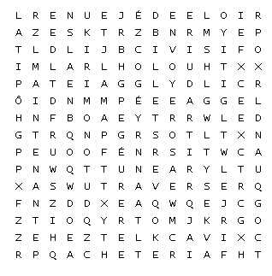

acheter – to buy
aimer – to like
envoyer – to send
étudier – to study
faire – to do
parler – to speak
traduire – to translate
travailler – to work
traverser - to cross
Allemagne – Germany
des billets – some tickets
une chambre – a bedroom
faire la cuisine – to do the cooking
faire les courses – to do the shopping
faire les devoirs – to do the homework
des glaces – some ice-cream
en ce moment – at the moment
le déjeuner – the lunch
une église – a church
un hôpital – a hospital
hier – yesterday
maintenant – now
une langue – a language
une lettre – a letter
un mot – a word
un pont – a bridge
des romans - novels
quand - when
il y a - there is
il y avait – there was

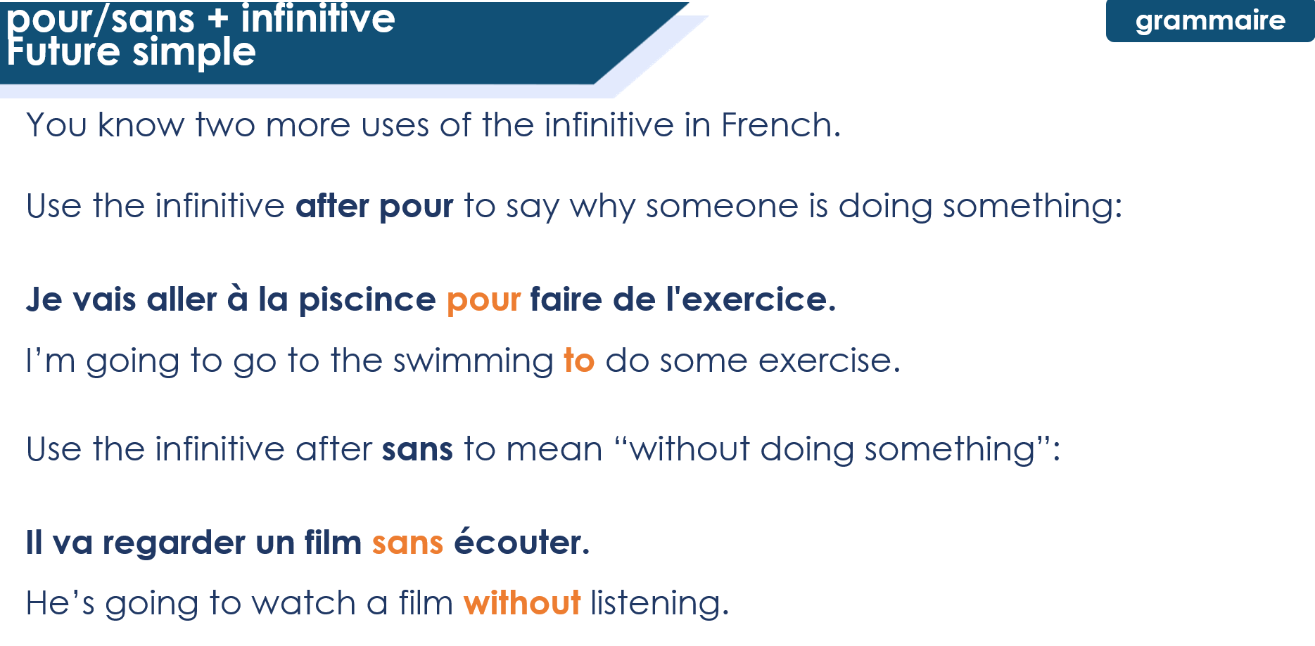
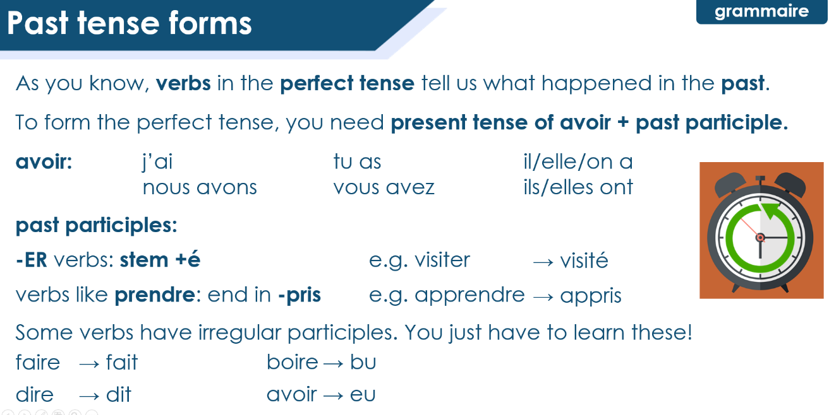
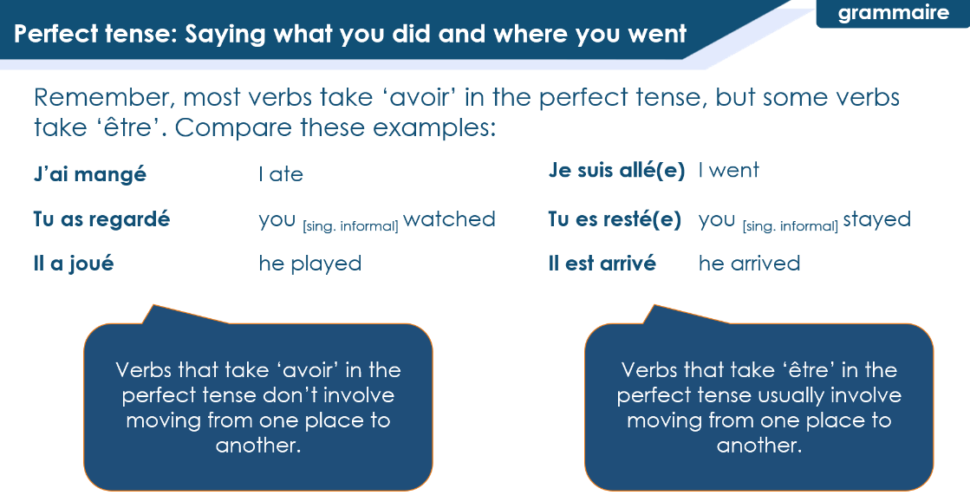
T2 / 1.2
T3 / 2.2
T3 / 1.2

