Revision sheet for AP2
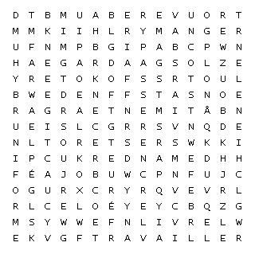

aimer – to like
demander – to ask
écouter – to listen
faire – to do
lire – to read
manger – to eat
parler – to speak
passer – to spend
porter – to wear
rester – to stay
travailler – to work
trouver – to find
un bateau - a boat
un bâtiment – a building
un cadeau – a present
un chien – a dog
une école – a school
un livre – a book
un professeur – a teacher
un uniforme – a uniform

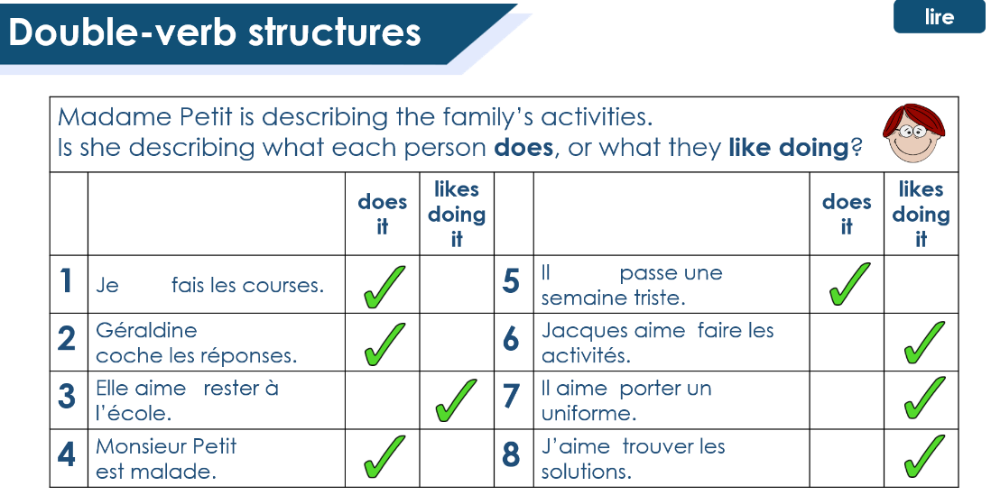
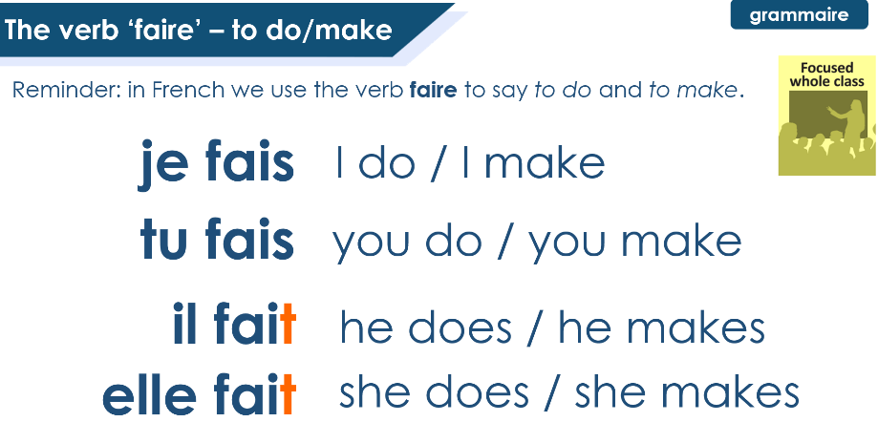
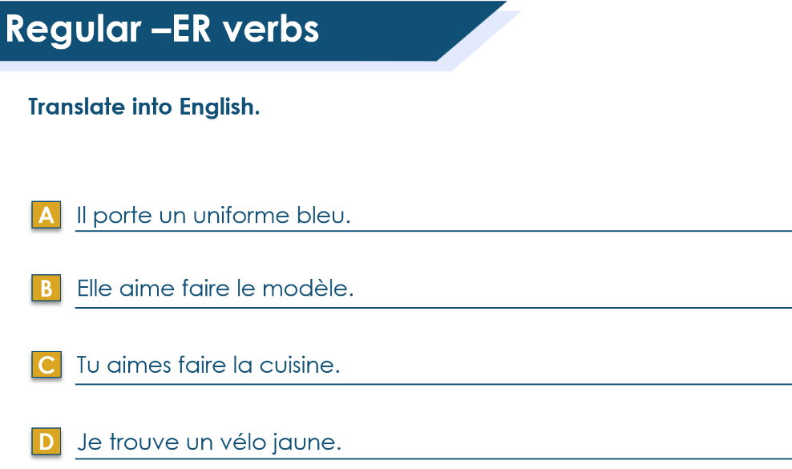
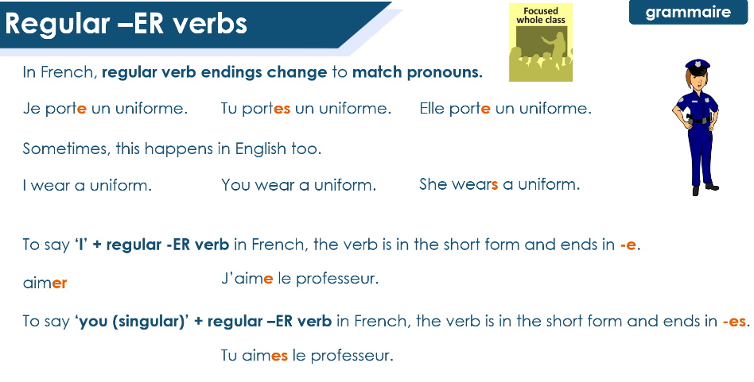
T2 / 3.2
T2 / 2.1
T2 / 3.1
T2 / 3.1

