- What is a tropical cyclone?
A weather hazard that consists of large, rotating storms. They are immensely powerful, traveling up to 157mph. They are between up to 400 miles wide and 5 miles high.
Key words
Continental crust – older, less dense plate.
Continental drift – the gradual movement of continents across earth’s surface.
Convection currents – hot magma rising through the mantle as it becomes less dense.
Geological time – recording how earth rock structure has changed over time
Immediate response – response the days and weeks immediately after
Long term response – response that goes on for months and years after the disaster
Natural hazard – an extreme event that happens naturally that causes harm to humans and the environment.
Oceanic crust – found under the oceans, the younger but denser plate.
Pangea – the supercontinent, when all land masses were joined together.
Primary effect: occurs as a direct result of the tectonic hazard e.g. the ground shaking and buildings collapse
Secondary effect: occur as a result of the primary effects e.g. buildings collapse, people made homeless
Tropical cyclone – a large rotating storm.
Tsunami – a large series of waves caused by tectonic activity.

Year 7 Natural Hazards
Knowledge Organiser

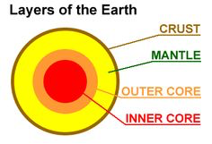
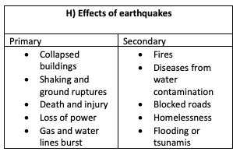
G) The distribution of earthquakes and volcanoes
- The majority are found along plate boundaries
- There is a large number of earthquakes and volcanoes found around the pacific plate (commonly known as the Pacific Ring of Fire)
- Volcanoes form at both constructive and destructive plate boundaries
- Earthquakes form at all three boundaries: Constructive, destructive and conservative
F) What is plate tectonic theory?
The theory that earth’s crust is broken into smaller pieces called plates. Those plates sit on top of molten magma in the mantle.

Newly formed crust at mid ocean ridges is less dense, but becomes more dense with age as it cools and thickens. This causes it to sink into the mantle at subduction zones due to the force of gravity. This is called slab pull. It is thought that the weight of the old and cold slab pulls the whole plate along with it.

The oceanic plate is pulled apart in the middle as the older, more dense rock sinks either side of it, resulting in sea floor spreading. Magma, rise from the mantle through the gap in the crust to form new land. The newly created land at the ridge is often quite tall, forming tall ridges. However, they eventually sink back down as they are spread away from the rising magma. This is called ridge push.
e) Has Japan always been where it is?
Alfred Wegener proposed the theory of Pangea, a supercontinent dating back around 250 million years ago. It is thought that over geological time, earth’s continents have drifted. We now call this continental drift.
H) Destructive plate boundaries
The oceanic and continental plates are moving towards one another. Ocean crust is dense (heavy) whereas continental crust is less dense. As a result, when the two plates meet, the oceanic plate will be forced underneath the continental plate and forced down towards the mantle. This is called a subduction zone. As the oceanic plate continues to subduct, pressure and friction increases as the two plates become stuck. Eventually this is released in a jerking motion, resulting in an earthquake.
D) Why does Japan suffer from natural hazards?
Japan is an island nation located in East Asia. The Pacific Ocean is to its east and the Sea of Japan to its west. Due to Japans physical location, it is prone to tropical cyclones as well as earthquakes. Japan has had to learn to live with its vulnerability to hazards. Typhoon Hagibis is an example of a cyclone which caused extreme damage. 74 people lost their lives, the heavy rainfall caused 850 landslides, 34,000 homes were without electricity, 110,000 without running water and 50,000 people living in shelters.
B) What conditions are needed for a tropical cyclone to form?
- Form between 5° and 30° latitude.
- Temperatures of at least 27°c
- The spinning of earth (the Coriolis effect)
C) How do tropical storms form?
- Warm moist air is evaporated at the earth’s surface, cools, condenses to form cumulonimbus clouds and heavy rainfall. This creates low pressure on the ground.
- The air which has now lost its moisture moves north and south towards 30° and begins to sink, creating high pressure.
- The low-pressure sucks in air from the surrounding high-pressure zone, also rising, evaporating and enlarging the cloud.
- The spinning of the earth causes the storm to spin.
G) Earthquake case study: Low Income Country (HIC)
Nepal 25th April 2015
Nepal was struck by an earthquake measuring 7.9 on the Richter scale. The epicentre was 80km north-west of Nepal’s capital Kathmandu.
- 9,000 people were killed, 3 million people were left homeless and entire villages were fattened.
- Cost of the damage was estimated at $5 billion.

G) Earthquake case study: High Income Country (HIC)
March 11, 2011 a magnitude 9 earthquake shook north-eastern Japan on the island of Honshu.
- 700 people were killed during the earthquake, 6,152 people injured.
- Infrastructure damaged e.g. roads, buildings, sidewalks.
- A tsunami, 40 metres high, killed more than 15,500 people. 450,000 people became homeless.
- $235 billion worth of damage, making it the costliest disaster in world history.

- How can risks from hazards be reduced?
Prediction | Recording physical changes such as earthquake tremors to help forecast when and where it might happen. Attempts to forecast when and where a natural hazard will strike based on current knowledge. Scientists think that it is impossible to entirely predict an earthquake and therefore this should not be relied upon as the only strategy to reduce the risk.
Protection | Actions taken before the hazard strikes to reduce its impacts, such as improving building designs. Japan has many earthquake proof buildings which are built to absorb earth tremors, fire resistant, steel frames which can sway and computer-controlled weights on roofs to reduce movement.
Planning | Actions taken to enable communities to respond to and recover from natural disasters e.g. evacuation plans, communication and warning systems. There is a simple drop, cover, hold on earthquake drill which takes place across Japan in many schools. September 1 in Japan is known as Disaster Prevention Day and millions of people participate in drills.
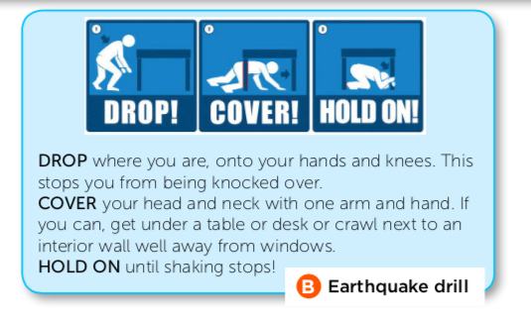
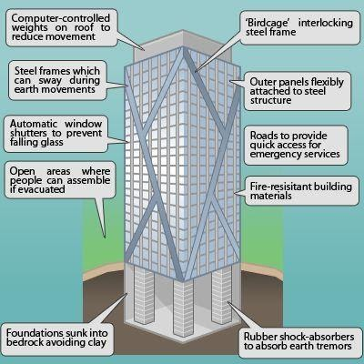
F) Japan as an example:
Over 126.8 million people live in Japan, an island country that lies along the Pacific Ring of Fire where the North American, Pacific, Eurasion and Philippine plates come together. Roughly 90% of all the world’s earthquakes and 80% of the largest ones strike here. Nearly 75% of people in Japan leave in areas at risk. Why do they choose to live here?

- Tokyo is one of the most economically and technologically advanced countries
- Japan’s dramatic landscape, including its dormant volcanos have become attractive tourist destinations
- Family – people do not want to move away from their friends and family
- Japan is seen as the most prepared country to deal with earthquakes. It invests a lot of money in earthquake proofing buildings, educating communities and learning from past mistakes.

I) Why do people live near tectonic hazards?
- Fault lines associated with earthquakes can allow water supplies to reach the surface. This is particularly important in dry desert regions.
- Some people may not be aware of the risks of living close to plate margins.
- Volcanoes can bring benefits such as fertile soils, rocks for building, rich mineral deposits and hot water.
- Better building design an withstand earthquakes so people feel less at risk.
- Earthquakes and volcanic eruptions don’t happen very often. They are not seen as a great threat in most people’s lives.
- People living in poverty have other things too thick about on a daily basis, such as money food, security and family.
- More effective warnings allows for people to evacuate.

