Year 7 Weather and Climate: Is weather in the UK becoming more extreme?

a) What is the difference between weather and climate?
Weather describes the conditions in the atmosphere over a short period of time. Examples of weather include whether it is sunny, cold, cool, cloudy, raining, snowing. However, climate describes the average weather patterns over a long period of time in a specific location. The Earth has many climate regions including tropical, desert, polar and temperate.

b) Why is it colder at the poles?
The temperature of a region drops the further it is away from the equator. This is due to the curvature of earth. The sun’s rays travel over a smaller area through the atmosphere to heat up the areas around the equator, making them much hotter. However, closer to the poles, the sun’s rays have to cover a much larger area of the planet including the atmosphere, making it much colder.

c) How does precipitation form?
Precipitation is the word that describes any moisture that falls from the sky e.g. rain, snow, sleat or hail. It happens due to the water cycle. The movement of water between the sea, air and land.
- Water in the ocean is heated by the sun, the molecules in the water become less dense and changes it into a gas. This is evaporation.
- The water vapour rises high up into the sky, where it is cooled and the molecules become denser, changing back to a liquid. This is condensation.
- When water vapour changes back to a liquid, it becomes too heavy to be held in the sky. It falls from the sky as precipitation (rain, snow, sleet, hail).
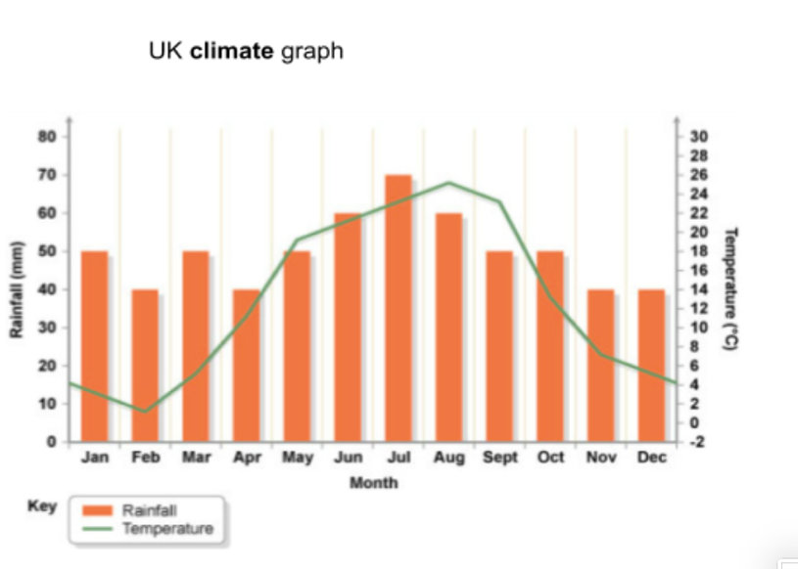
- Water, once it reaches the earth, moves back to oceans, rivers and lakes on top of the ground and under the ground. This is run off.

d) What is the climate of the UK like?
The climate of the UK is called a temperate climate. This means that temperatures are cool and rainfall is plenty, but not too extreme. The average temperature in the summer is 15.6 °C in the summer and there is 1,416mm of rainfall. We can see this spread out throughout the year on a climate graph.
- Precipitation is shown as a bar graph.
- Temperature is shown as a line graph.
e) What are the different way rainfall forms?
- Frontal rain – warm air is less dense than cold air. When two pieces of air meet and one is colder than the other, the warm air is forced to rise above the colder air. The warmer air travels high up into the atmosphere, eventually falling as rain.
- Relief rain – when air is pushed towards a hill/mountain, it is forced upwards as it cannot pass through. The higher up the air goes, the cooler it is. This forces the water vapour in the air to cool and condense, forming rain on the side of the hill the air moved up.
- Convectional rain – on a hot day when the sun is shining on the earth’s surface, it heats up the air above it. Warm air can hold more water vapour, and because its so hot, lots of water is evaporated. The warm air rises high up into the atmosphere and falls as rain.

f) What other factors impact on the climate in the UK?
- Altitude – this means how high a place is above sea level (flat ground). For every 100 metres in height, the temperature goes down by 1°C. This means that hilly or mountainous regions are colder.
- Air masses – an air mass is a large body of air that changes the temperature of a place. A place in the south-east of England will be warmed up by the tropical continental air mass bringing hot and dry air. Whereas, a place in the north west of Scotland will be impacted by the Polar maritime air mass, meaning it is cold and wet.
g) What is extreme weather?
Extreme weather is a weather event that is very different to the average (normal) weather conditions and they usually have negative impacts. There have been many extreme weather events in the UK and scientists think they are becoming more common:
- In 2018, there was an extremely cold snow storm called the ‘Beast from the East’.
- In 2019, the UK broke a record temperature in the summer of July at 38.7°C in Cambridge.
- In 2020, the wettest February on record was recorded
- In 2020, the third hottest day on record happened in Heathrow at 37.8°C.

h) Why is the Earth’s climate changing?
- Surrounding the Earth is the atmosphere. The atmosphere (the air above us) contains a number of gases such as carbon dioxide, water vapour, methane. These are natural gases.
- Solar radiation passes through the atmosphere. When solar radiation from the sun reaches
- Earth’s land and water, they absorb some of it.
- However, excess heat is re-radiated back towards space.
- The gases in the atmosphere absorb the heat radiation and this keeps earth warm. They are therefore called greenhouse gases.
- They are critical to life on earth as without the blanket of greenhouse gases trapping in
- heat, Earth’s temperatures would be bitterly cold, and humans would be unable to survive.
Humans burn lots of fossil fuels to make energy to power factories and homes. Fossil fuels released more carbon dioxide into the atmosphere, making the greenhouse effect stronger. Our planet has warmed roughly 1°C since the industrial revolution.

i) How is a warming planet leading to more extreme weather?

- We are experiencing more heatwaves as the air temperatures are increasing. A heatwave In the UK is when temperatures are over the threshold limit for that region, with 28c for London, 27C for the home counties, 26C further North and West, 25C in Scotland, Wales and Northern Ireland.
- Hotter air temperatures will cause more evaporation is taking place. As the air gets warmer, it can hold more water vapour. This can lead to more intense rainstorms.

- More intense rainstorms can lead to drought in the ground. This is because rainstorms lead to floods which means all the water will rush away from the ground to the river or sea.

j) What are the impacts of extreme weather?

Social: Figures from the Office for National Statistics shows that there were an extra 614 deaths recorded in the summer of 2019.

Economic: Roads and rail transport is affected as tarmac melts and the steel on the railway lines expand and buckle. This causes further disruption to commuters.
- Good weather attracts many people to the seaside e.g. Southend on Sea which is good for the economy.
- Crops struggle to grow in extreme heath

Environmental: Vegetation and land dry out in such extreme heat. Animals find it difficult to cope.

