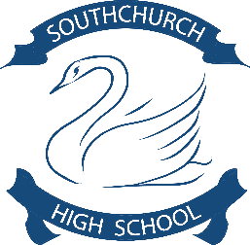
Southchurch High School
Assessment Point Test
AP2
Surname
Forename
Class | Year 9
Teacher

- Hour
April 2024

Question | Maximum Mark | Mark Awarded
1 | 18
Total | 18
Grade | 1-9 | Grade

- You must work in silence
- Attempt every task
- Write in black pen
- This must be your own work

Access Arrangements Evidence (Tick as appropriate)
Reader
Scribe
Coloured Paper
Extra Time

Art & Design. Year 9 KS3. Theme “surrealism”
Assessment Criteria
12 points for your Art (painting/drawing)

-Refinement, clarity (2 points)

-Form - Shape (2 points)

-Blending / shading (2 points)

-Perspective (2 points)

-Relevance to theme assigned (2 points)

-Completion (2 points)

6 points for Evaluation

What have I created and with what materials (2 points)

What techniques did I use (2 points)

Which art movement and artist inspired me (2points)

Task: To create an observational drawing of the image provided.

Media: pencil and acrylic paint.

Size: A4 Landscape.

You will be marked on the assessment criteria above.

Your teacher will read through the assessment criteria before you start.

Good luck!

