Mansa Musa Fact File
Timeline of The Life of Mansa Musa, 1280-1337  1280: Born into the royal family of the Kingdom of Mali.  1312: Appointed Mansa of the Kingdom of Mali.  1324: Performed Hajj  1325: Gao is conquered by force. Gao was the capital of the neighbouring Kingdom of Gao and one of the oldest and most important trading centres in West Africa.  From 1326: Spread Islam throughout West Africa by building mosques, libraries and universities.  1327: Built Djinguereber Mosque in Timbuktu, the Kingdom of Mali’s largest city.  1337: Mansa Musa dies. | - What do we already know about Mansa Musa?  Mana Musa was the leader of the Kingdom of Mali from 1312 to 1337. During this time, Mansa Musa became an extremely wealthy leader and transformed the Kingdom of Mali into a place rich in culture, learning and religion. Mansa Musa was also successful in battle and conquered Gao and Timbuktu, both important trading cities. After he died, his son Maghan took the throne, but this led to conflict with another noble family, the Salaymans and eventually, the Kingdom of Mali fell to the Kingdom of Songhay. | 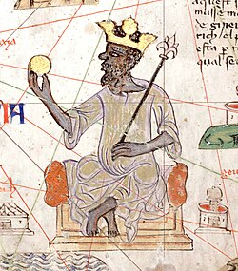  - Source A: Depiction of Mansa Musa from the 14th Century.  - Interpretation 1 - Mansa Musa’s Legacy written by historian P. James Oliver.  “Mansa Musa left a legacy of cultural and religious values that endured long after his death…marketplaces became living encyclopaedias of the world where silks…were displayed beside ivory, drums, copper and cattle…The University of Sankore continued to grow…Stately mosques stood as examples of architectural innovation and centres of education and public prayer…it was a time of glory, a time to remember.”
- Mansa Musa’s Hajj
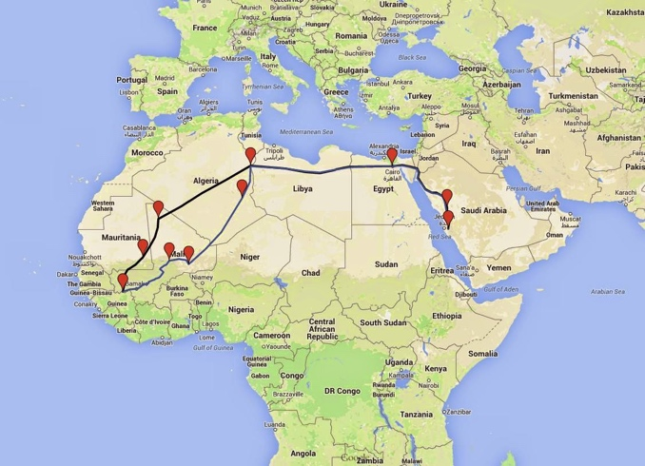
In 1324, Mansa Musa showed his dedication to Islam by performing the Hajj pilgrimage. The pilgrim journey to Makkah was 4,000 miles long (similar to the distance between the UK and USA) and took just over a year to complete. The Hajj not only sent out important messages to the world about Mansa Musa’s religious beliefs, it also emphasised his wealth and love of learning.

- Timbuktu
While Mansa Musa was in Makkah, his army generals expanded the Kingdom of Mali by conquering neighbouring countries. The capture of Timbuktu in 1324 was significant. Under Mansa Musa, it was transformed from a small desert community into an important trading centre, making Mansa Musa even richer. However, Timbuktu was famed more for its wisdom (architecture, libraries and universities), than its wealth. As a result, capturing Timbuktu also increased the Kingdom of Mali’s reputation as a centre of learning.

