- Impacts of flooding
Floods can cause damage to homes and possessions as well as disruption to communications. Lower Income Countries (LICs) tend to be affected more than Higher Income Countries (HICs). This is partly because LICs do not have the resources to prevent flooding or deal with the aftermath of flooding.
B) Hydrograph is a graph that shows how a river channel responds to rainfall. It shows how rainfall affects the discharge of a river. The amount of water in the river channel and the speed at which it is flowing.

A) Factors affecting flood risk
Physical
- Precipitation – heavy rainfall
- Relief – steep land will increase risk of flooding
- Geology – impermeable rock can increase risks

Human
- Urbanisation – concrete surfaces and drains
- Deforestation – reduces interception
- Farming – involves removing trees/trampling on land
c | c) The impacts of river flooding: The River Thames 2014
Social | - 2500 people were at risk from rising flood waters and were unable to find safe placed. This resulted in the evacuation of 1000 people.  - People were unable to return home for up to 6 months. Many were unable to return home to collect personal belongings.  - Roads were cut off and people were unable to visit family, friends, local amenities or work.
Economic | - In total, the river caused £500 million in damage. This was largely from insurance claims.  - People’s homes were damaged and personal belongings destroyed, this would have put a financial strain on the community.  - Damage to roads/railways meant that people were unable to get to work. For many who owned businesses or worked for local businesses, they lost income.  - Looters took advantage of the abandoned homes and stole valuable items from homes.  - Additional strain on emergency services. Extra soldiers and police officers had to be called in to the area to support the community.
Environmental | - The River Thames burst its banks. Due to high discharge, erosion of the banks and beds took place, altering the natural course of the river.  - Flooded farmlands destroyed crops. Natural habitat of animals destroyed.  - Vegetation uprooted and damage to gardens.  - Receding flood water deposited pollution throughout the affected areas, impacting on local wildlife.
D) Why is the risk of flooding increasing in the UK?
- Urbanisation: although rates of urbanisation have steadied, urban areas are expanding.
- Population growth: more landed is needed to build on, includes building on flood plains.
- Climate change: The jet streams are transferring warmer air to the Polar Regions. This is melting ice caps which increases the volume of water in the ocean. Warmer climate leads to further evaporation of water (of which there is more in the ocean) increasing the intensity of storms in the UK.
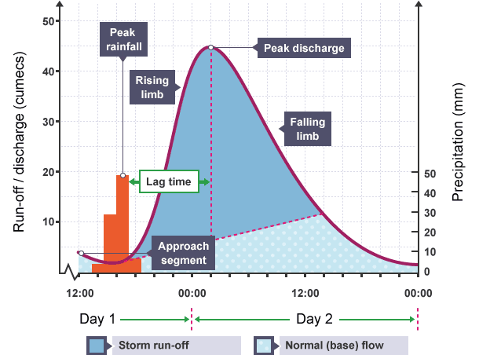
Course | Characteristics
Upper | Here the river’s gradient is steep, the river channel is narrow and there is a low volume of water.
Middle | Here the gradient is more gentle, volume and velocity have increase and the river is wider and deeper.
Lower | The land is flat and the river has become even wider and deeper. It has the highest velocity here.
F) Key Words
- Velocity: the speed of the river
- Volume: the amount of water in the river system.
- Discharge: the amount of water in the river passing a given point. It is measured by multiplying the velocity and volume
- Gradient – how steep the river is.
G) The long profile of a river
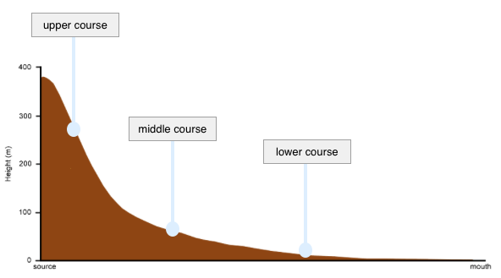
- Fluvial processes (river processes)
Erosion
- Hydraulic power – the force of the water hitting the bed and banks of the river
- Abrasion – sediment within the water rubs against the bed and banks wearing them away
- Attrition – stones carried by the river knock into one another
- Solution – mild acids in the river erode rocks
Transportation
- Traction – large pebbles rolled along the seabed
- Saltation – a ‘hopping’ or ‘bouncing’ motion of particles too heavy to be suspended
- Suspension – particles carried within the water
- Solution – dissolved chemicals carried within the water
Deposition
- Occurs when the river drops its load
- Occurs when the velocity of a river decreases

- Waterfall: Landform resulting from erosion in upper course
- The river runs over bands of hard and soft rock
- The soft rock is less resistant and so is eroded more easily (abrasion and hydraulic action).
- Over time, this is eroded further, the hard rock above is undercut and as a result, over hangs
- Eventually the overhanging hard rock will collapse. This rock and the force of the water will form a plunge pool at the bottom of a waterfall
- Overtime, the waterfall will retreat upstream
J) Meander: Landforms resulting from erosion and deposition in the middle course
Rivers develop large bends called meanders because:
- The river current is fastest on the outside bend
- On the outside bend the river is deeper, there is less friction
- As a result, erosion can take place here. Sediment can be carried in suspension that further erodes the banks by abrasion resulting in the formation of a river cliff
- On the inside bend the river is slower. Here, the river channel is shallower so there is more friction
- As the river has less energy, sediment is deposited on the inside bend
- Over time, this can accumulate (build up) to form a slip off slope

M) How are rivers managed to reduce the risk of flooding?
Hard Engineering
- Dams and reservoirs: large amounts of water can be held behind the dam, but these are very expensive to build
- Channel straightening: the river flows faster through straighter parts of the channel, which reduces risk of flooding
- Embankments: the banks of the river channel are artificially raised which increases the channels capacity
- Flood relief channel: an additional channel is constructed, usually parallel to the original river channel
Soft Engineering
- Tree planting: trees help to intercept heavy rainfall and reduce the amount of water reaching the channel
- Flood plain zoning: land use next to the river is planned so that high value land uses are placed further away from the channel
- River restoration: the river is returned to its natural state, meanders are formed which then helps to slow down the speed of the river and reduces the discharge further downstream

L) Floodplains, levees, estuaries: Landforms resulting from deposition in the lower course
- Floodplain – flat land on either side of the river. When a river bursts its banks, it will deposit sediment which builds up over time.
- Levees – these are raised banks that run along the course of the river. When a river overflows, its velocity decreases and it begins to deposit its load. The largest, coarsest material will be deposited first and will form raised banks called levees at the side of the river.

K) Ox bow lake formation
1. Erosion causes the outside bend of the 2 meanders to become narrower
2. During times of high discharge (a flood), the river will break through the neck in search of the shortest route
The new course of the river means that water no longer enters the old meander. Deposition takes place and cuts this off, leaving behind an ox bow lake.
- What is a river?

A river is a large natural stream of flowing water. They are found on every continent on earth.

If we think of all the water on earth as making up 100% - oceans make up 97.2 % of this, glaciers and ice sheets make up 2.15% and rivers make up only 0.65% of water on earth.
Global rivers knowledge organiser
Year 8
- Why are rivers so important?

- Drinking water: many people on earth rely on rivers as their source of drinking water.
- Settlement: this means where people live. Many people live on something called a delta which is a landform created by a river.
- Crops: billions of people around the world rely on rivers to irrigate (give water) to their crops.
- Fish: 12 million tonnes of freshwater fish are caught each year which provides people with another source of food and also income (money).
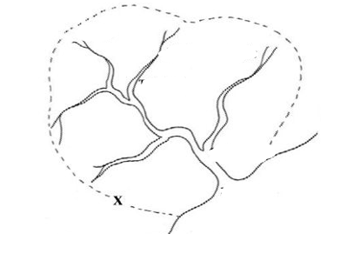
C) Where are the world’s major rivers?
1. The Nile River, Africa.
This is the world’s longest river and is 4100 miles long. It flows from the south to north of Africa into the Mediterranean Sea.
2. The Amazon River, South America.
Although it is not the longest river as it is 4000 miles long, the Amazon River is the largest river in the world.
3. The Yangtze River, China.
The Yangtze is Asia’s longest and most important river. It is 3,915 miles long and flows into the East China sea.
4. The Mississippi River, USA.
Flowing for 2,350 miles through the heart of the United States into the Gulf of Mexico.
5. The Ganges River, India.
The Ganges is located in northern India and flows for 1,569 miles from the Himalayan Mountains to the Bay of Bengal.
6. The Thames River, England.
The Thames in England is one of Europe’s most historic rivers and flows through the capital of England, London. It starts its’ journey in Kemble and ends in Southend-on-Sea where it enters the North Sea.
D) How are rivers formed?
Water reaches land through something called the hydrological cycle – the water cycle.

This is made up of
- Evaporation: liquid changing to a gas
- Condensation: gas changing to a liquid
- Precipitation: rain, snow and hail
- Runoff: water moving across the land
- Transpiration: water vapour released from plants and soil
E: A river drainage basin: an area of land drained by a river and its tributaries
Mouth
Confluence
Watershed
Tributary
Source

