Blinding Lights (short version) – The WEEKND
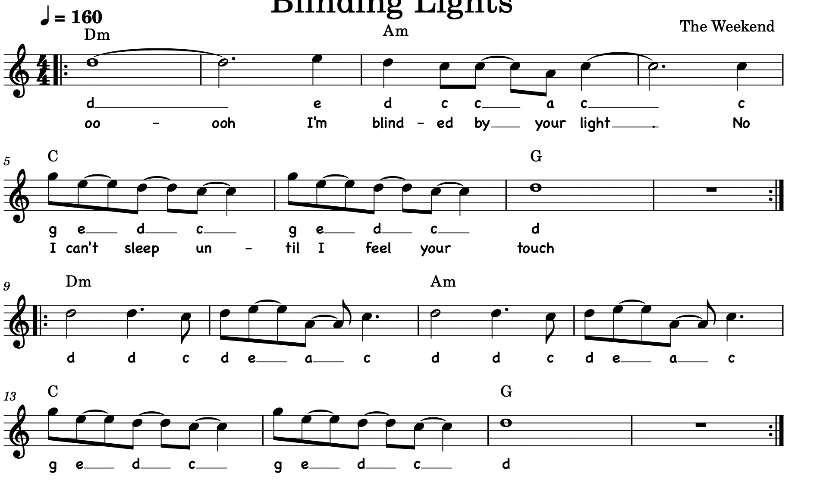

All-star – Smash mouth (the song from Shrek)
