Curley’s wife | 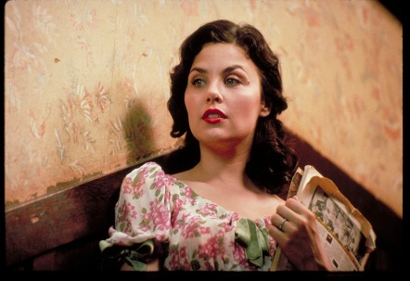

Background
____________________________________________________________________________________________________________________________________________________________
____________________________________________________________________________________________________________________________________________________________

Key moments
________________________________________________________________________________________________________________________________________________________________________________________________________________________________________________________________________________________________________________________

Things she says
________________________________________________________________________________________________________________________________________________________________________________________________________________________________________________________________________________________________________________________

Actions - things she does
________________________________________________________________________________________________________________________________________________________________________________________________________________________________________________________________________________________________________________________

How do we as readers feel about her?
________________________________________________________________________________________________________________________________________________________________________________________________________________________________________________________________________________________________________________________

