Character List
Old Major, a boar
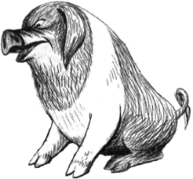
Napoleon, a pig
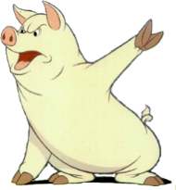
Snowball, a pig
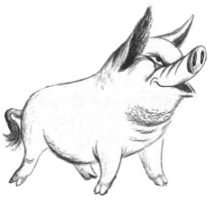Squealer, a pig
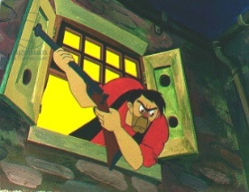
Mr Jones, a farmer
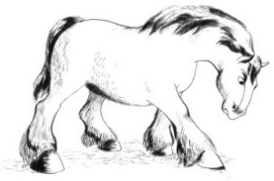
Boxer, a horse
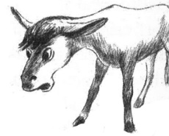
Benjamin, a donkey

