‘Animal Farm’: revision
You will need to write an assessment on ‘Animal Farm’. Before you do, you will need to revise some of the main characters and events from the novel.
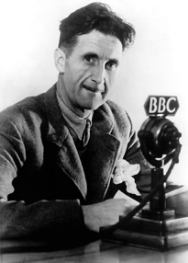 | Who is this man? What happened during his life to influence his work on ‘Animal Farm’?
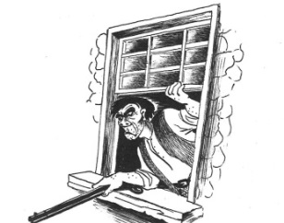  Farmer Jones | How did farmer Jones treat the animals in a cruel way? (Chapter 1)
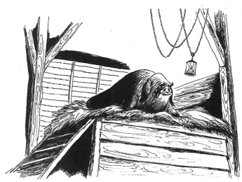 | What does Old Major say life will be like after the Rebellion?
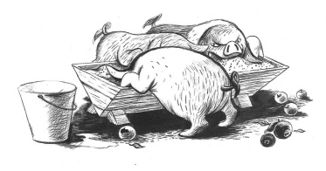 | The pigs keep the milk and apples for themselves at the end of Chapter 3. Why is this not fair?
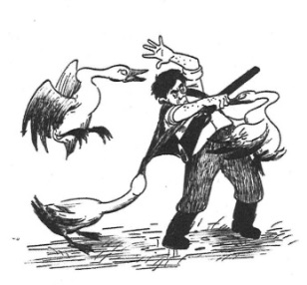 | How was Snowball the hero of the Battle of the Cowshed (Chapter 4)?
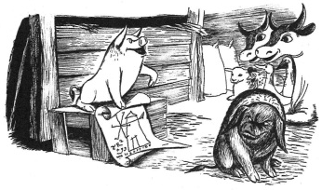 | What happens to Snowball after he debates with Napoleon about the Windmill?

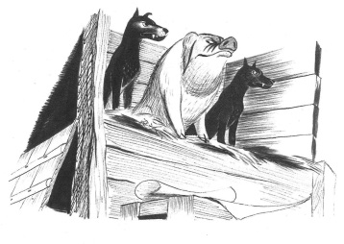 | What does Napoleon do to make himself the leader of Animal Farm?
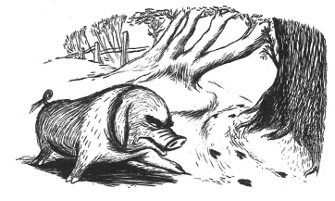 | Napoleon makes the other animals hate someone. a) Who does he make them hate? b) Why?
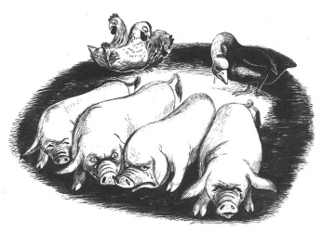 | What happens in the show trials?
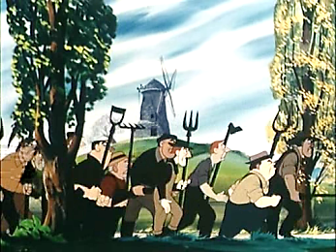 | How was the Battle of the Windmill different to the Battle of the Cowshed?
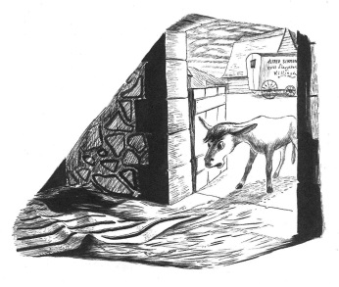 | How does Boxer die?
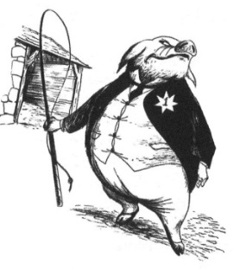 | How do the pigs act like humans at the end of ‘Animal Farm’?
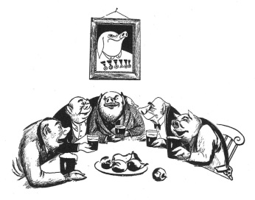 | Was the Rebellion a success?

